##### 

##### 

##### 

##### 

##### 

Top Tasks Survey

The Evergreen State College

O C T O B E R 7, 2 0 2 0

##### 

##### T A B L E O F C O N T E N T S

T A B L E O F C O N T E N T S 2

**Executive Summary** **4**

**Survey Methodology** **5**

Designing the Survey 6

Collecting Responses 6

**Results** **7**

Question 1 7

Question 2 8

Big Tasks 9

Medium Tasks 10

Current Students 14

Big Tasks 15

Medium Tasks 15

Prospective Students 19

Big Tasks 20

Medium Tasks 20

Additional Notes 23

**Recommendations** **23**

Tailor key pages to top tasks 23

Prefer topical content to FAQ pages 24

Use step-by-step content for process instructions 24

**Appendices** **25**

A: Complete Task List 25

B: Detailed Results 28

Full survey results, broken down by relationship and category 28

Raw data from SurveyMonkey 28

## 

# Executive Summary

Top Tasks is a framework designed by George McGovern to determine the primary reasons that a website’s users are coming to the site. Lullabot ran a Top Tasks survey for The Evergreen State College from August 14, 2020 through September 4, 2020. This survey asked respondents to categorize themselves into a type of visitor (current student, prospective student, etc) and then asked them to choose the 5 tasks from a list of 75 that they considered most important for their use case.

* The primary audience for this survey was **prospective and current students**. Anyone who identified themselves as part of another audience was thanked for their time and their survey session was ended.
* In total **614 students** completed the survey of which **387 were current and 227 were prospective**.
* Results followed a common pattern where **4-6 major tasks bubbled to the top** while the rest spread out in a long tail with the bottom 20-30 or so tasks only receiving a few selections each.
* All the tasks were assigned a category as part of the survey analysis. In general, the most popular topics were related to **costs, academics, and admissions.**
* **Prospective students** tended to be more interested in **tasks related to costs and admissions**. In particular “Tuition and Fees” was by far their highest concern when visiting the site.
* **Current students** tended to be more interested in **tasks related to costs and academics**. The most commonly voted topics for current students were “Course catalog”, “Registering for classes” and “Financial aid (process, applying, deadlines)”.
* Both groups were very interested in topics of **financial aid**, but generally they were **more interested in the “how”** (process and deadlines) **than the “what”** (programs available).
* **Tasks related to general information** (about evergreen, about olympia, etc) fell towards the bottom of the survey, although they were more popular with prospective students than current ones.
* Our recommendations based on these results and the site’s content are **tailor key pages to top tasks**, **prefer topical content to FAQ content**, and **use step by step content for process instructions**.

The rest of this report will give more details on this process and the results and insights that were gained.

# Survey Methodology

A Top Tasks survey consists of 50-75 tasks or topics that users might be in search of when they come to a website. Respondents are instructed to scan the list and select a maximum of five tasks that are most important to them. The list is presented in a random order for each respondent, to prevent tasks from being weighted based on their position. Respondents are encouraged to trust their initial instincts and not spend any more than 5 minutes on the process. The average time spent to complete the survey was 1 minute, which is right where it should be. The more that users trust their initial impressions, the more accurate the results are.

## Designing the Survey

The first step in the process is creating the list of tasks that respondents will choose from. Typically, we will create a very broad list of tasks, and then go through a process of slimming it down. This is done by removing tasks that are duplicates or not important, and combining tasks that are very similar. The initial list was taken from the following data sources:

* Top 100 terms that users put into site search
* Top 100 pages that people visit based on results of searches
* Top 50 most visited pages
* MES usability tests and interviews
* Interview with a college placement professional on questions her students most often want answered from a university website

The first list had 386 tasks, which was trimmed down over several weeks to the 76 tasks we eventually settled on. When compiling this list, we tried to make sure and get a broad range of different types of tasks, appealing to both current and prospective students. Additionally, the individual tasks should not be too broad or too focused. After several iterations we settled on the final list, which can be found in Appendix A.

## Collecting Responses

Once the list was complete, the survey was put together and distributed through the Evergreen website. After 2 weeks, we saw that current student responses were greatly outnumbering prospective students. In an effort to even that balance, we then sent the survey to an additional 2500 prospective students via email, using a list provided by <who?> All told the survey ran for three weeks.

# Results

The survey contained two questions. The first asked respondents to describe their relationship to Evergreen State College, and the second contained the lists of tasks to choose from.

## Question 1

This question asked respondents to describe their relationship to Evergreen State College. The options were as follows.

* Current student
* Prospective Student
* Parent of a Current or Prospective Student
* Alumni
* Faculty/Staff
* Other.

Anyone who selected Alumni, Faculty/Staff, or Other was taken to the end of the survey, while the other three were taken to the second question, where they were asked to rank their top tasks. 1,024 respondents answered question 1.

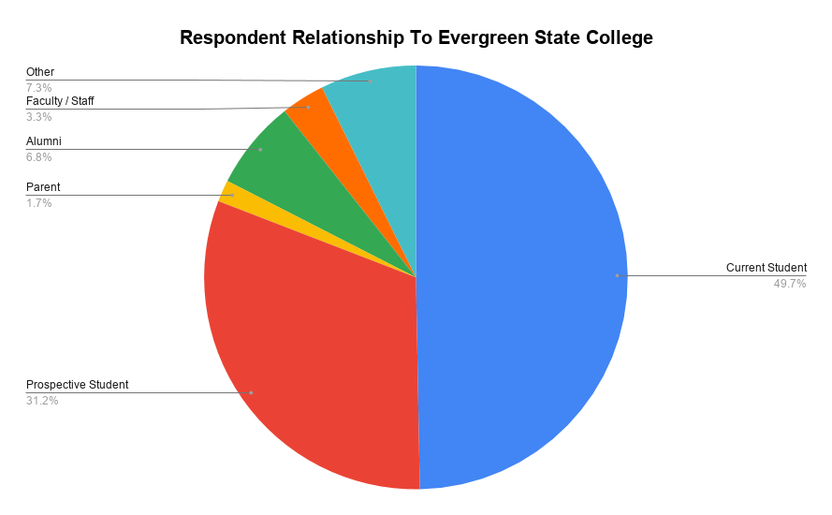

Of these respondents, 625 went on to complete the task selection, a completion rate of just under 74%, which is pretty decent.

## Question 2

Question two presented the students with the list of tasks (see Appendix A) and asked them to choose the five most important to them. Typically this will result in a few tasks getting a large number of votes, with the remaining tasks gradually trailing with the last 20-30 only receiving a few votes each. This survey was no exception. As seen in the chart below, there is a significant drop off after the first four tasks, a steep decline in the next four, another sharp drop around 18, and then a slow trail off for the rest.

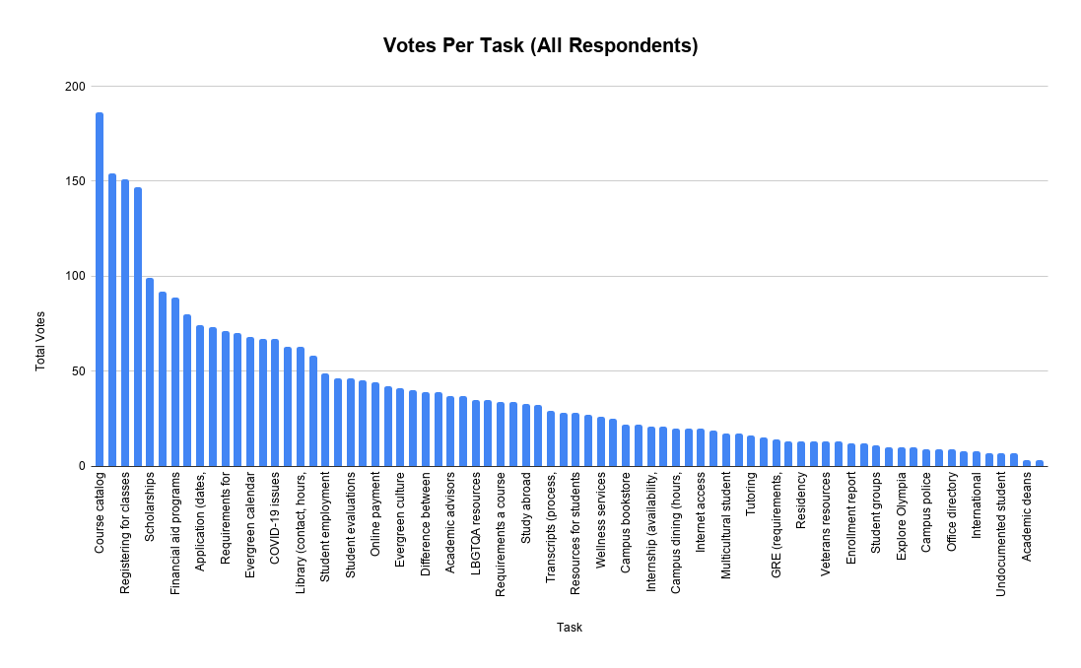

When analyzing and ranking these tasks, we divide them up in four sections, each with roughly 25% of the votes. The top 25% are Big tasks - the ones that respondents are most passionate about or interested in. The next 25% are Medium tasks, the third 25% are Small tasks, and the last 25% are Tiny tasks. You’ll want to focus most of your effort on the Big and Medium topics, since those are the ones that your user base cares about the most.

The Big and Medium tasks were as follows, in ranked order. (Details on the categorization are in the next section.)

#### Big Tasks

| **Task** | **Category** |
| --- | --- |
| Course catalog (locations, times, faculty) | Academics |
| Registering for classes | Academics |
| Financial aid (process, applying, deadlines) | Costs |
| Tuition and fees | Costs |
| Scholarships | Costs |

#### Medium Tasks

| **Task** | **Category** |
| --- | --- |
| Paths of Study | Academics |
| Financial aid programs | Costs |
| Online learning | Academics |
| Application (dates, deadlines, requirements) | Admissions |
| Requirements for a degree | Admissions |
| Total cost of a degree | Costs |
| Evergreen calendar (events, holidays, etc.) | Campus Life |
| Bachelors degree programs | Academics |
| COVID-19 issues | Campus Life |

The following chart shows how the Big, Small, Medium, and Tiny tasks broke down. Note that due to the size of the chart, not all titles are readable. Lullabot has provided a spreadsheet which has a more complete breakdown of the survey for those interested in more details. This spreadsheet can be found in Appendix B.

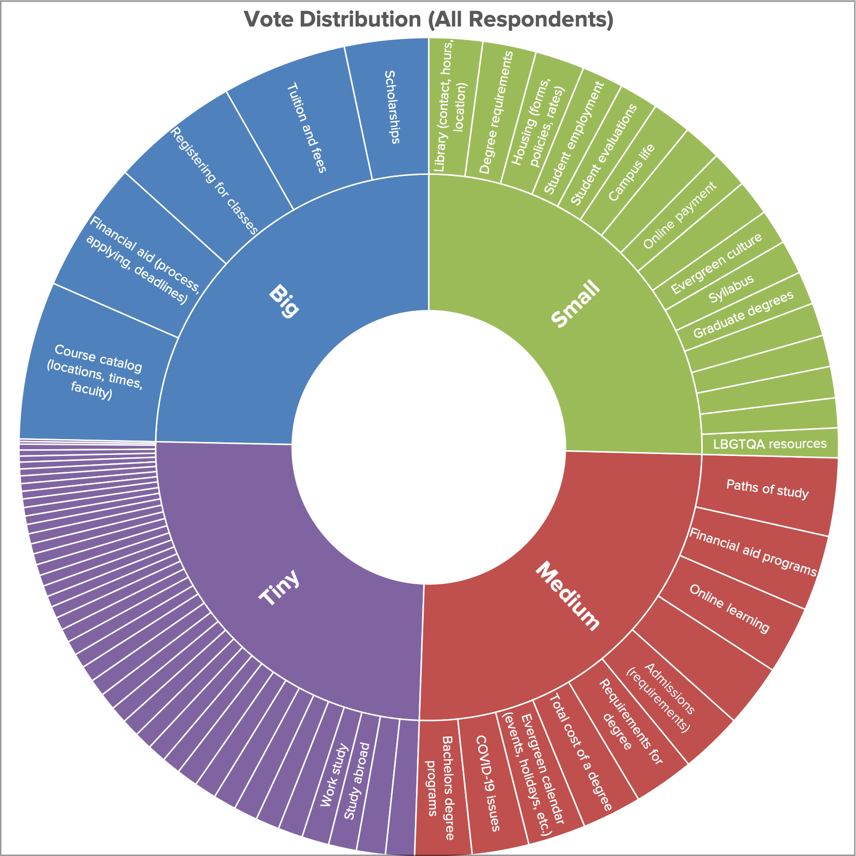

In addition to the specific tasks that are most popular, it is useful to examine the broader trends behind those tasks. In looking at these tasks, we found ourselves seeing some trends in the types of tasks that were being voted on. **The most popular tasks tend to be highly “transactional”** - they are related to getting a specific question answered or a specific task completed. **The less popular tasks tended to be more “informational”** - the kind of information you might look at when you are browsing or doing more generalized research.

In order to expand on this we did a loose categorization exercise in association with Evergreen staff, placing each task into one of the following categories.

* Academics
* Costs
* Admissions
* Campus Life
* Campus Locations
* Non-Academic Resources
* About Evergreen

We then aggregated votes per category across all respondents. Additionally, we normalized the results due to the fact that not every category had the same number of tasks in it. A category with a high number of tasks but a medium number of votes per task will still have a very large number of total votes, whereas a category with few tasks but a large number of votes per task will show as being unpopular. This is despite the fact that some of its individual tasks may be much more popular than any of the individual tasks in other categories.

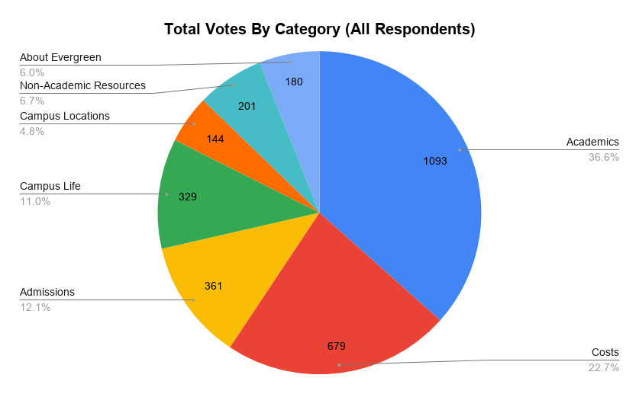

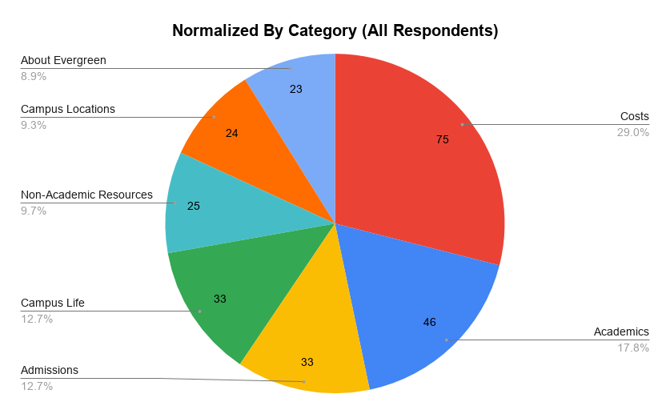

In both cases, the **top three categories were Academics, Costs, and Admissions**. The tasks in these categories comprised **71.4% of all votes**. While Academics received the highest number of votes in total, Costs received the highest number of votes per topic. This indicates that while **respondents were broadly interested in Academics**, the individual tasks related to **Costs engendered a lot more passion**. In fact, **three of the top five tasks overall were related to Costs**. Specifically, across the board, the “how” of financial aid (deadlines, process) was more highly voted than the “what” of financial aid (programs available.)

In addition to analyzing the results in total, we were also able to analyze current and prospective students as distinct data sets. This allows us to determine if there are any differences in interest or intent between the two groups.

### Current Students

The data for current students generally followed the trends shown for all respondents combined, not surprising given that current students were over 60% of the survey respondents. Current students shared a large number of items in their big and medium task lists with the survey total, and both groups were heavily weighted towards interest in Costs and Academics as categories. However there were some interesting differences as well.

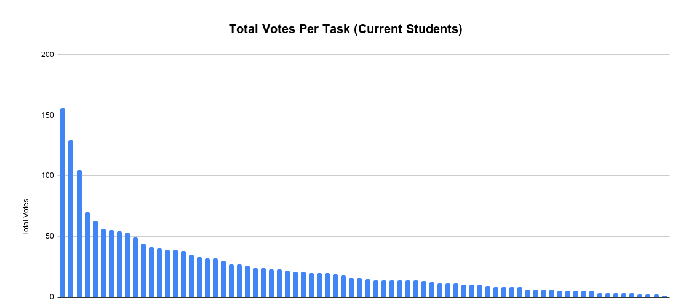

As you can see in this chart, there were three tasks that were far more popular than the rest, after which there was a gradual dropoff in the rest of the tasks. Those three tasks were **Course catalog, Registering for class, and Financial Aid**. Together these three tasks comprised almost **21% of the total responses for current students**. The rest of the Big and Medium tasks for current students were as follows.

#### Big Tasks

| **Task** | **Category** |
| --- | --- |
| Course catalog (locations, times, faculty) | Academics |
| Registering for classes | Academics |
| Financial aid (process, applying, deadlines) | Costs |
| Tuition and fees | Costs |

#### Medium Tasks

| **Task** | **Category** |
| --- | --- |
| Evergreen calendar (events, holidays, etc.) | Campus Life |
| Financial aid programs | Costs |
| Library (contact, hours, location) | Campus Locations |
| Scholarships | Costs |
| Online learning | Academics |
| Paths of study | Academics |
| Degree requirements | Admissions |
| Student evaluations | Academics |
| Student employment | Non-Academic Resources |

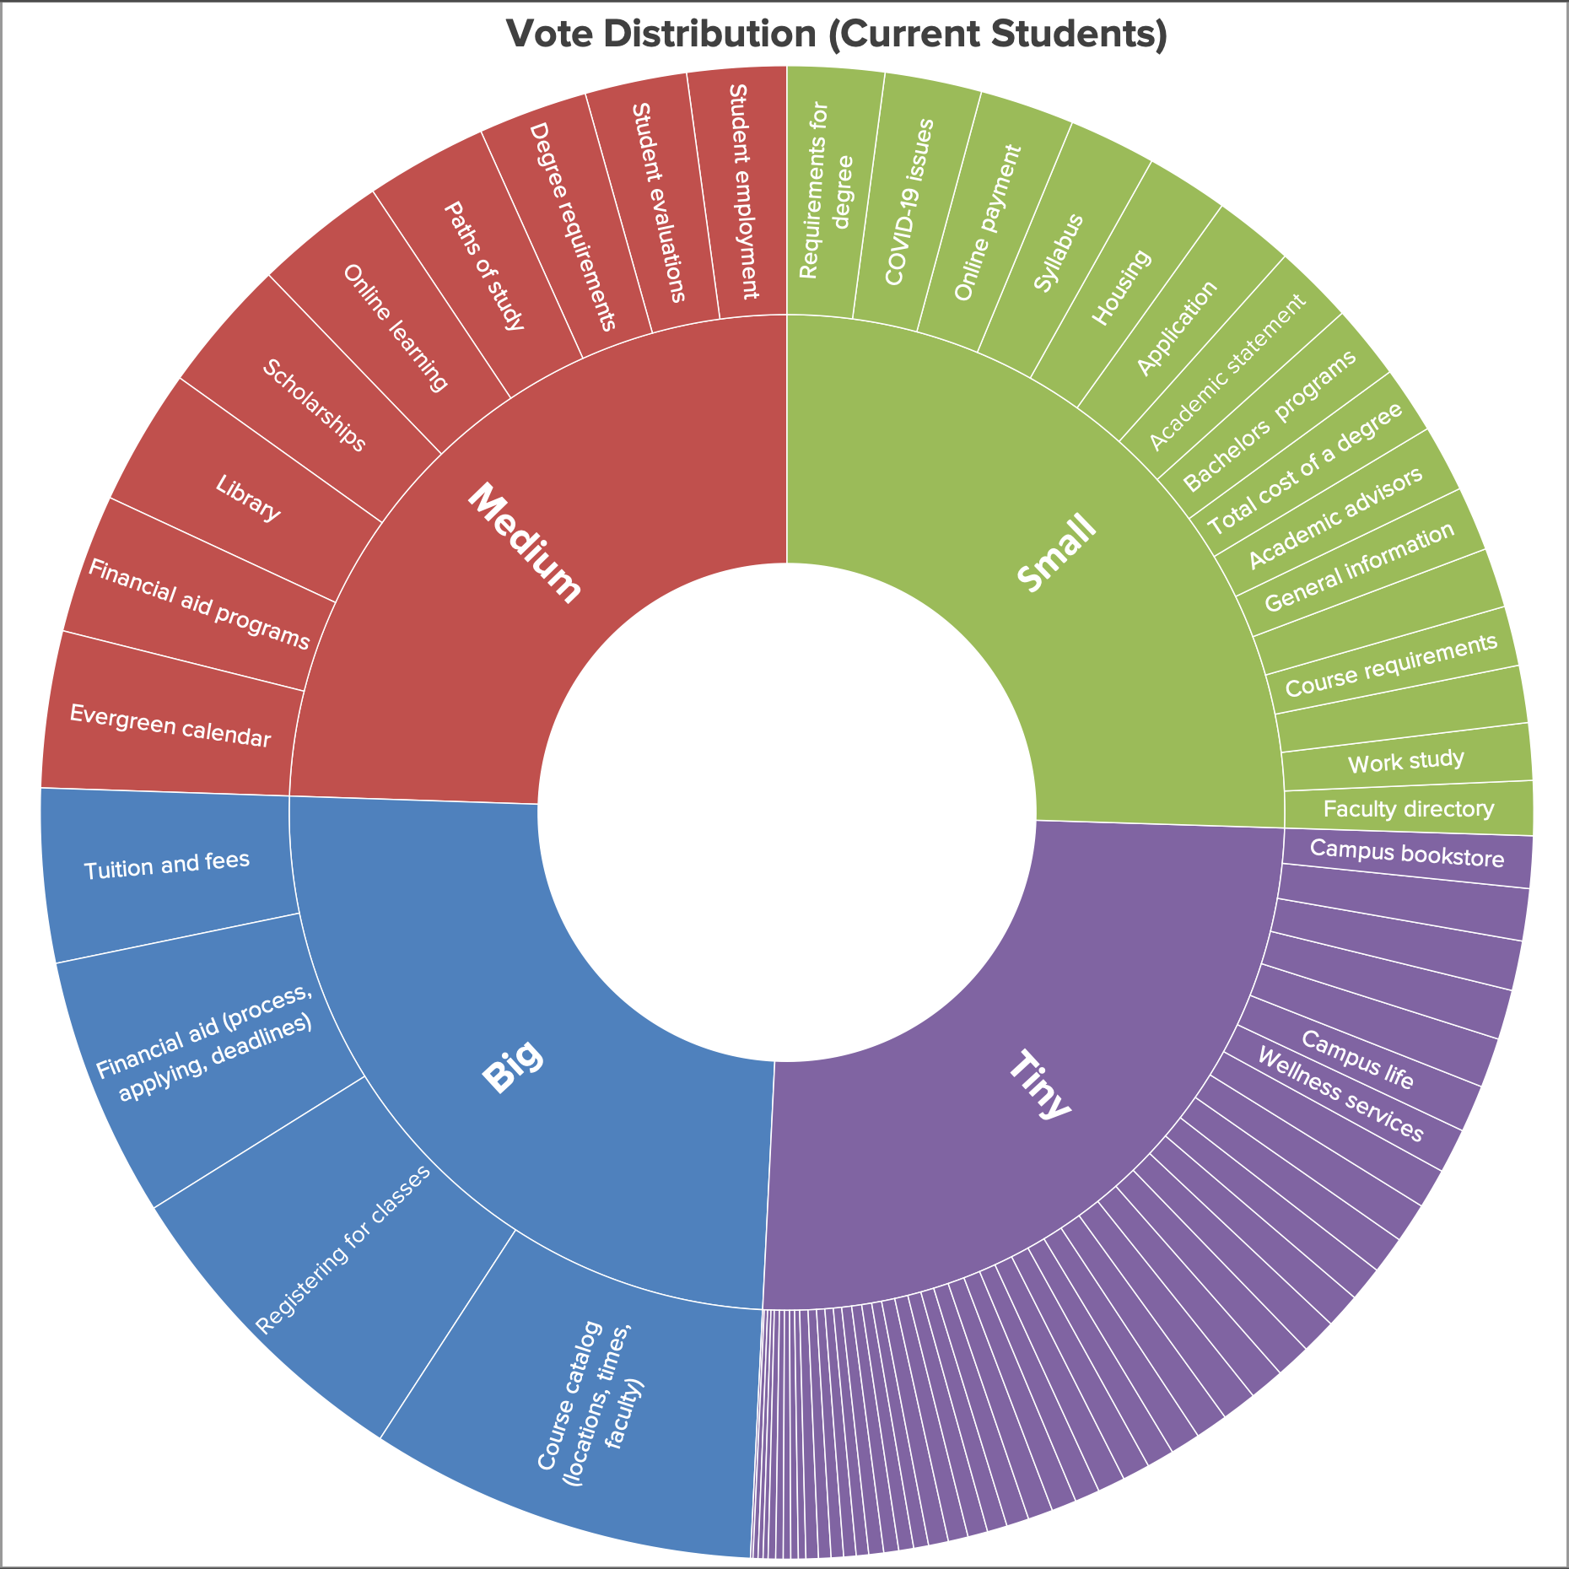

The most popular categories for current students were **Academics, Costs and Admissions**. Academics received by far the most votes (42.2%) with Costs second (21.4%) and Campus Life third (10.7%). Together these three categories comprised almost **75% of all votes cast**. Normalizing the results balanced Costs and Academics (28% and 21% respectively) with Campus Life remaining in third.

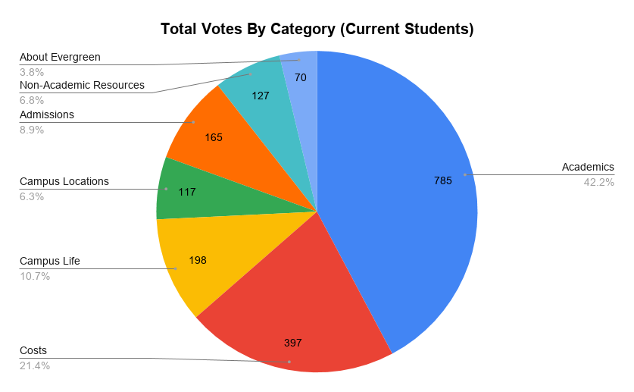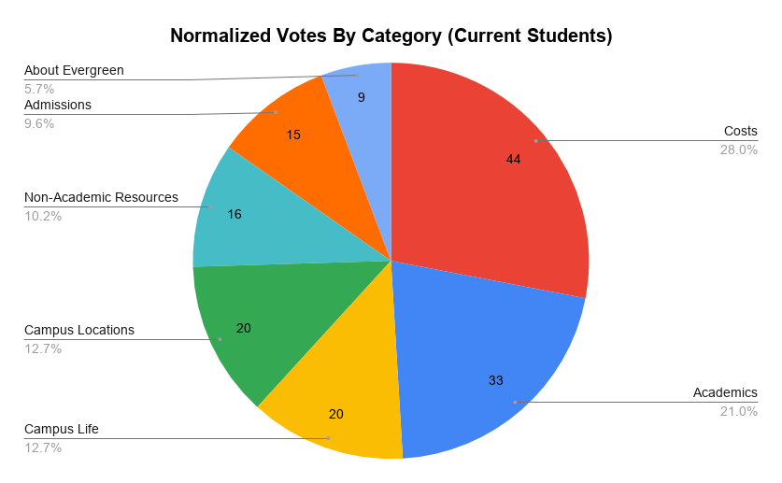

While it is expected that current students would care a great deal about academics, this again shows that issues of cost are central to the student experience, even after they have already enrolled.

### Prospective Students

The results from prospective students were interestingly different, and worth highlighting.

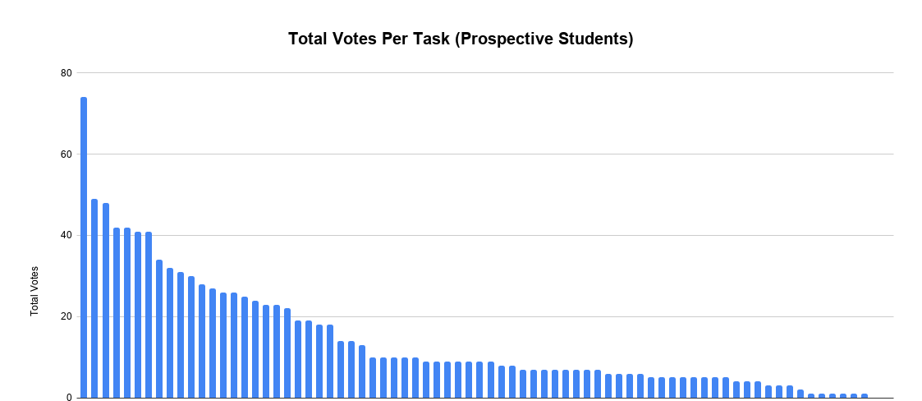

As you can see, unlike the other distributions, prospective students cared about one task far more than any other. That task was “Tuition & fees”, receiving almost twice as many voted as the second highest task. The next two tasks were “Financial aid (process, applying, deadlines)” and “Admissions (deadlines)”. The next four after that were fairly even, and then there is something more akin to a more standard drop off for the rest. The rest of the Big and Medium tasks were as follows.

#### Big Tasks

| **Task** | **Category** |
| --- | --- |
| Tuition and fees | Costs |
| Financial aid (process, applying, deadlines) | Costs |
| Admissions (requirements) | Admissions |
| Scholarships | Costs |
| Total cost of a degree | Costs |

#### Medium Tasks

| **Task** | **Category** |
| --- | --- |
| Paths of study | Academics |
| Application (dates, deadlines, requirements) | Admissions |
| Bachelors degree programs | Academics |
| Financial aid programs | Costs |
| Difference between Evergreen and other universities | About Evergreen |
| Requirements for degree | Academics |
| Course catalog (locations, times, faculty) | Academics |
| COVID-19 issues | Campus Life |
| Campus life | Campus Life |

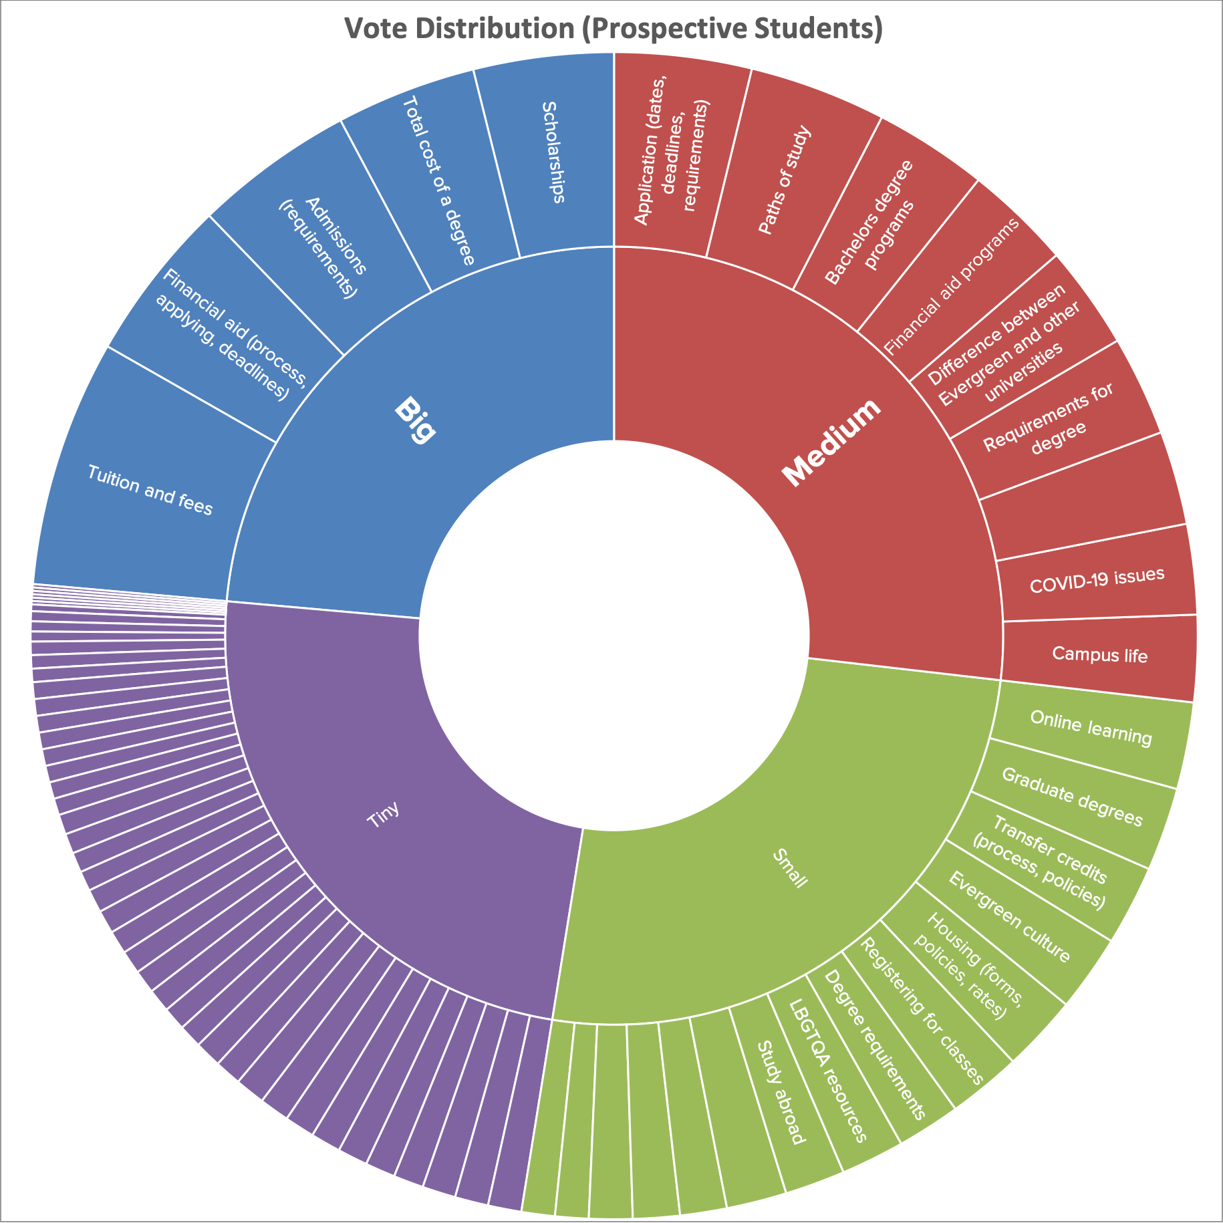

In fact, issues related to costs comprised almost 20% of the top 5 tasks, with “Admissions (requirements)” being the only outlier. This is further reflected as we dive into the categories.

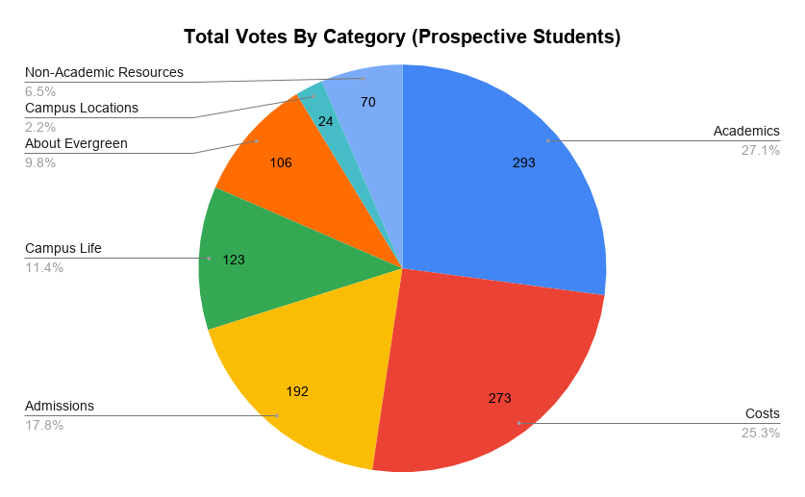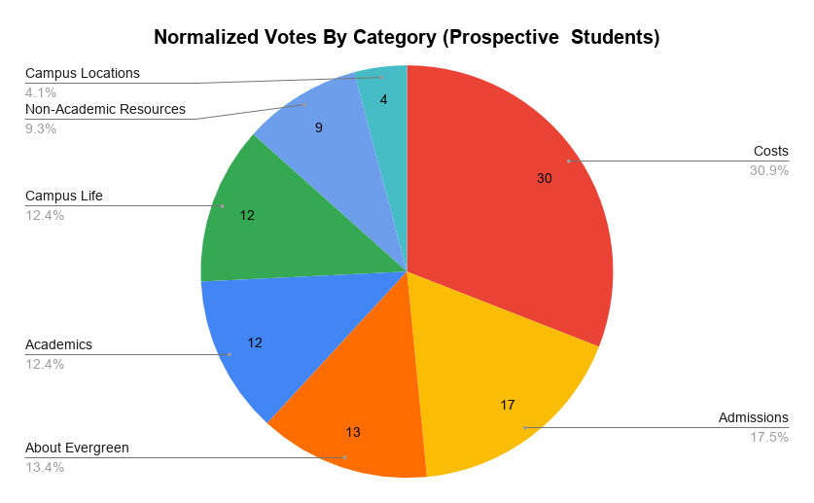

The normalized votes really tell a different tale than the straight aggregated votes. After normalization, Academics drops from first to fourth most popular, with only 12 votes per task. In the meantime, Costs and Admissions jump to first and second respectively. Particularly notable is About Evergreen which is third most popular after normalization. This is the only place where About Evergreen wasn’t one of the least popular categories, indicating that prospective students, while driven by logistical concerns, still have a lot of interest in the Evergreen experience.

### Additional Notes

These results have undoubtedly been impacted by the needs of students in light of the COVID-19 pandemic. Tasks such as eLearning are undoubtedly much higher than usual, while tasks such related to visiting the college are certainly much lower. It would be worthwhile to run this exercise again when things return to normal in order to gain a more complete understanding of how the pandemic has affected the priorities of Evergreen’s visitors.

# Recommendations

As a result of our findings, Lullabot recommends the following.

### Tailor key pages to top tasks

Explore ways to **surface content to the front page and other major landing pages which is more suited to the tasks and categories that current and prospective students are interested in**. Currently the site’s main navigation features Academics, Costs and Admissions very prominently, which is excellent. There is also an icon navigation bar high on the page for links to common destinations like the course catalog. However beyond that, the actual content on the page is very **heavily focused on high level marketing** content which would be classified as About Evergreen. This includes student profiles, an informational video, non-academic resources, and Evergreen news. Mixing in more applicable content will bring users into the site and improve their experience with the site and thus with Evergreen.

### Prefer topical content to FAQ pages

**Focus content creation on answering student questions without resorting to FAQ pages**. FAQ pages generate a lot of traffic, but generally fail in answering questions well. [No More FAQs: Create Purposeful Information for a More Effective User Experience](https://alistapart.com/article/no-more-faqs-create-purposeful-information-for-a-more-effective-user-experi/) from A List Apart goes into this problem in detail. Instead, create purposeful content that focuses on common student tasks in a way that both informs on the topic but also answers their common questions. This will not only improve their experience, but it is great for SEO.

### Use step-by-step content for process instructions

For common tasks or processes that are more complex, **use a content structure that provides a step by step overview** of the task, where users can jump off at any step for more details as needed. The state of Georgia uses this kind of structure for topics like [how to get a non-commercial driver’s license](https://georgia.gov/apply-georgia-drivers-license-class-c). Again, this approach makes for great SEO since Google is often scanning website text for question and answer formats, which it surfaces when people search for those questions. Identifying the multi-step processes associated with the top tasks would provide a solid group of content to focus on.

# Appendices

## A: Complete Task List

| **Task** | **Category** |
| --- | --- |
| Alumni employment (rates, types) | About Evergreen |
| Difference between Evergreen and other universities | About Evergreen |
| Evergreen culture | About Evergreen |
| General information about Evergreen | About Evergreen |
| Getting to Evergreen (map, directions, transit) | About Evergreen |
| Parking information(cost, passes, services) | About Evergreen |
| Virtual tour of Evergreen | About Evergreen |
| Visiting Evergreen | About Evergreen |
| Academic advisors (hours, how to meet, drop-in) | Academics |
| Academic deans | Academics |
| Academic fair | Academics |
| Academic policies | Academics |
| Academic statement (examples, requirements) | Academics |
| Audit / nonadmitted classes | Academics |
| Bachelors degree programs | Academics |
| Course catalog (locations, times, faculty) | Academics |
| Enrollment report | Academics |
| Faculty directory | Academics |
| Graduate degrees | Academics |
| Individual Learning Contracts (deadline, policies) | Academics |
| Internship (availability, process) | Academics |
| Native Pathways (eligibility, locations, program) | Academics |
| Online learning | Academics |
| Paths of study | Academics |
| Registering for classes | Academics |
| Requirements a course fulfills | Academics |
| Requirements for degree | Academics |
| Student evaluations | Academics |
| Syllabus | Academics |
| Tacoma campus | Academics |
| Tutoring | Academics |
| Weekend and evening classes | Academics |
| Admissions (requirements) | Admissions |
| Application (dates, deadlines, requirements) | Admissions |
| Apply for graduate program | Admissions |
| Degree requirements | Admissions |
| GRE (requirements, pre-requisites, timing) | Admissions |
| International admissions | Admissions |
| Part-time options | Admissions |
| Residency requirements | Admissions |
| Sample schedule | Admissions |
| Transcripts (process, pricing, etc) | Admissions |
| Transfer credits (process, policies) | Admissions |
| Campus dining (hours, menus, services) | Campus Life |
| Campus life | Campus Life |
| Campus policies | Campus Life |
| Campus safety | Campus Life |
| COVID-19 issues | Campus Life |
| Evergreen calendar (events, holidays, etc.) | Campus Life |
| Explore Olympia | Campus Life |
| Housing (forms, policies, rates) | Campus Life |
| Internet access | Campus Life |
| Student groups | Campus Life |
| Campus bookstore | Campus Locations |
| Campus police | Campus Locations |
| Library (contact, hours, location) | Campus Locations |
| Office directory | Campus Locations |
| Recreation center (classes, hours, map) | Campus Locations |
| Wellness services | Campus Locations |
| Financial aid (process, applying, deadlines) | Costs |
| Financial aid programs | Costs |
| Graduate program financial aid | Costs |
| Online payment | Costs |
| Scholarships | Costs |
| Total cost of a degree | Costs |
| Tuition and fees | Costs |
| Western Undergraduate Exchange | Costs |
| Work study | Costs |
| Career services | Non-Academic Resources |
| LBGTQA resources | Non-Academic Resources |
| Multicultural student resources | Non-Academic Resources |
| Resources for students with disabilities | Non-Academic Resources |
| Student employment | Non-Academic Resources |
| Study abroad | Non-Academic Resources |
| Undocumented student resources | Non-Academic Resources |
| Veterans resources | Non-Academic Resources |

## B: Detailed Results

### [Full survey results, broken down by relationship and category](https://docs.google.com/spreadsheets/d/1PoUuFPOfMzrAnWbNYmypF0G6zBUKnTeEwt8wVCnAHXU/edit#gid=0)

### [Raw data from SurveyMonkey](https://www.dropbox.com/sh/8yoa32fevrhqqq6/AADgZMl3Bpj6yaOEh8hsEs5na?dl=0)